

INSERT UNIT-SPECIFIC INFORMATION HERE

***SHARP Links***

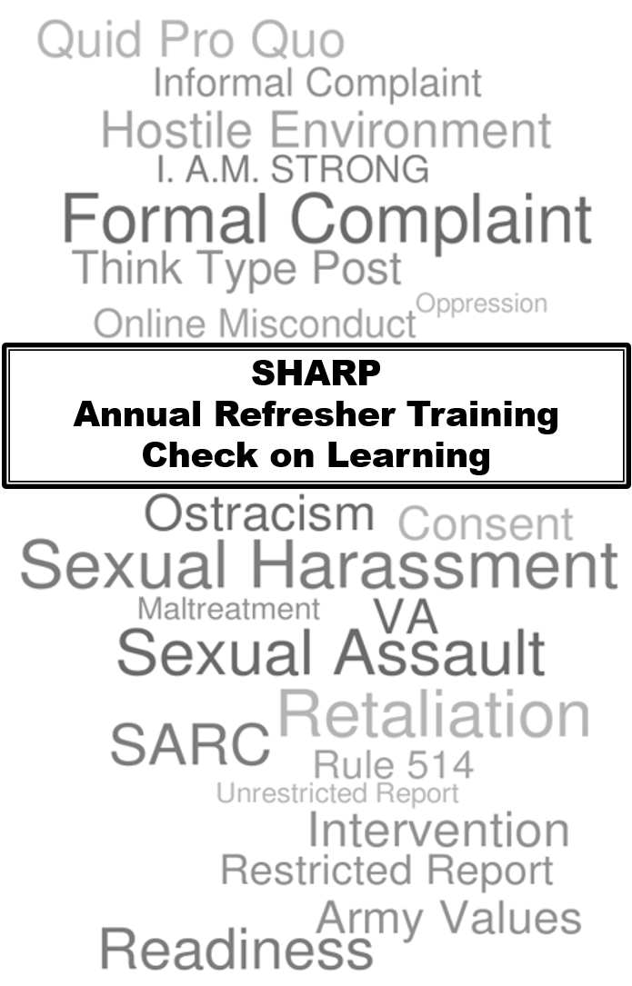

**DOD Safe Helpline - Sexual Assault Support for the DOD Community**

http://www.safehelpline.org//

1-877-995-5247

**Army Sexual Harassment/Assault Response and Prevention Website**

http://www.army.mil/SHARP

**DOD Sexual Assault Prevention and Response Website**

http://www.sapr.mil

**Army Criminal Investigation Command (CID)**

http://www.cid.army.mil/

**National Guard Bureau**

http://www.nationalguard.mil/Leadership/Joint-Staff/J-1/SAPR/

**Helping an Employee Recover from an Assault**

http://www.opm.gov/policy-data-oversight/worklife/reference-materials/traumaticevents.pdf

**Department of Veterans Affairs**

https://www.vets.gov/health-care/health-conditions/military-sexual-trauma/

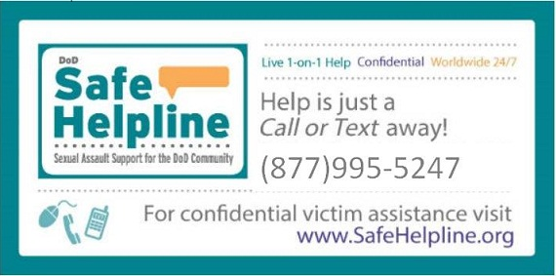



- @USArmySHARP



- Army SHARP



- @USArmySHARP

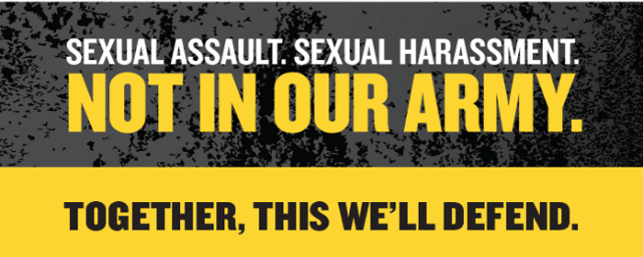

1. How can *sexual harassment* and *sexual assault* impact unit cohesion?

2. Why is it important to address and prevent even the slightest act of *sexual harassment*?

3. When does the Army’s policies on *sexual harassment* apply to Soldiers?

4. How long after a *sexual harassment* incident does a Soldier have to file a *formal complaint* of *sexual harassment*?

5. What are the 5 key questions asked to determine whether a specific incident or behavior constitutes *sexual harassment*?

1.___________________________________

2.___________________________________

3.___________________________________

4.___________________________________

5.___________________________________

6. What are the 3 categories of *sexual harassment*?

1.___________________________________

2.___________________________________

3.___________________________________

7. What are the 2 types of *sexual harassment*?

1.___________________________________

2.___________________________________

8. If a Soldier is uncomfortable with confronting inappropriate behavior, what other responses are available to them to address the behavior?

9. What are some administrative actions Commanders can impose for *sexual harassment offenders*?

10. How should a Command Team respond to an *unrestricted report* of a *sexual assault* incident?

11. Define ‘consent’ in your own words.

12. What is the difference between a *sexual act* and *sexual contact*?

13. What is the maximum sentence for rape under the UCMJ?

14. If one places themselves in a vulnerable situation, who is responsible if a sexual assault occurs - *the victim or the perpetrator*?

15. What type of *reporting option* will not trigger an investigation and therefore not hold the offender accountable?

16. What is the purpose of *Rule 514*?

17. What transfer options do sexual assault victims have when requesting an expedited transfer/reassignment?

18. How long does a Commander have to approve or disapprove an expedited transfer/reassignment request?

19. What is a Military Protection Order (MPO) and can they be enforced by civilian authorities off a military installation?

20. What 3 actions constitute *retaliation*?

1.___________________________________

2.___________________________________

3.___________________________________

21. Define ‘ostracism’ in your own words.

22. What are some types of *online misconduct*?

23. Members of the Army team should apply what 3 things when using electronic communication devices?

1.___________________________________

2.___________________________________

3.___________________________________

24. What are the 5 steps of *Bystander Intervention*?

1.___________________________________

2.___________________________________

3.___________________________________

4.___________________________________

5.___________________________________

25. *Whom can you contact for additional SHARP resources?*