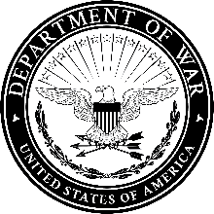

Office Symbol Date

MEMORANDUM FOR [Soldier, Unit]

SUBJECT: Review and Rescission of Approved Religious Accommodation (RA) Request

1. You are hereby notified that your approved RA is subject to review and rescission (cancellation) based upon Army Directive (AD) 2026-09, “Grooming Standards and Religious Accommodations”, dated, 04 June 2026.

2. If you choose to request continued accommodation, the submission requirements are outlined in the AD.

a. If you choose to re-submit your request, you must follow the guidelines in enclosures 1-3 of the AD and FRAGO 2 to EXORD 263-25 and re-submit NLT 45 calendar days from this counseling.

b. Your previously approved RA remains valid until a final decision is made by the Assistant Secretary of the Army (Manpower and Reserve Affairs). You are protected and do not need to change your current authorized appearance or uniform wear during this entire re-evaluation process, even if the review takes longer than the SECWAR’s directed 90-day review period.

c. If you choose not to re-submit, or if you submit your request after the 45-day deadline, your current RA may be rescinded. If rescinded, you will be required to immediately comply with AR 670-1 grooming standards for non-accommodated Soldiers.

d. If your re-submitted request is ultimately disapproved, you may request separation in accordance with applicable policy.

FIRST LAST
RNK, BR
Commanding

I acknowledge receipt of this notification on _____________________.

FIRST LAST
RNK, BR

